NATIONAL SPORTS DAY CELEBRATION REPORT — SVCOP

Date: 29 August 2025 (Friday)
Venue: SVCOP Sports Grounds, RVS Nagar, Chittoor
Organized by: NSS Unit, Sri Venkateswara College of Pharmacy
Under the leadership of:
- Principal: Dr. D. Jothieswari
- Academic Coordinator: Prof. C. Radhika
- Faculty Coordinators: Ms. K. Jeevana, Dr. P. Rupalatha, Mr. Y. Kesava Reddy
1. Event Context & Significance
National Sports Day in India commemorates the birth anniversary of hockey legend Major Dhyan Chand and falls on 29 August every year. In 2025, the theme was “Sport to Promote Peaceful and Inclusive Societies”, emphasizing unity through sport.
2. Objectives
- Encourage physical fitness and wellness among students and staff.
- Cultivate teamwork, leadership, and sportsmanship.
- Reinforce the NSS Unit’s commitment to holistic student development and national values.
3. Organizing & Leadership Structure
Role | Person
Principal & | Dr. D. Jothieswari
Academic Coordinator | Prof. C. Radhika
NSS members | Ms. T. Madhavi Latha, Dr. E. Kavya Sri
Faculty Coordinators | Ms. K. Jeevana, Dr. P. Rupalatha, Mr. Y. Kesava Reddy
NSS Volunteer Pack | Final-year B.Pharm, PharmD students

4. Event Activities & Schedule
Organized kabaddi and Kho- Kho for boys and girls.
5. Participation & Resources
- Participants: NSS volunteers, students across all programs, faculty, staff
- Sports Equipment: Balls, bibs, stopwatches, nets
- Logistics: Audio systems, first-aid kit, refreshments (water/snacks)
- Awards: Trophies or medals for winners; certificates for participation
9. Conclusion
The National Sports Day on 29 August 2025 at SVCOP was a resounding success—marked by unity, energy, and purposeful leadership. Under the strategic guidance of the NSS Unit leadership and dedicated faculty coordinators, the day underscored the institution’s ethos of holistic development and community bonding.

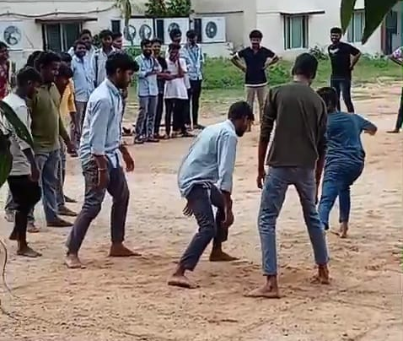

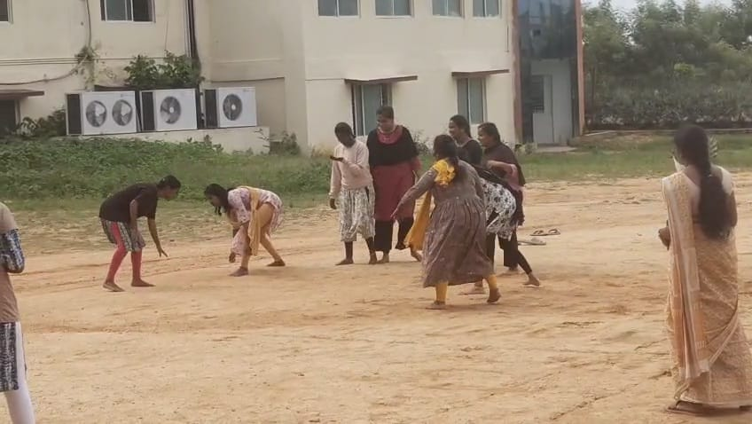

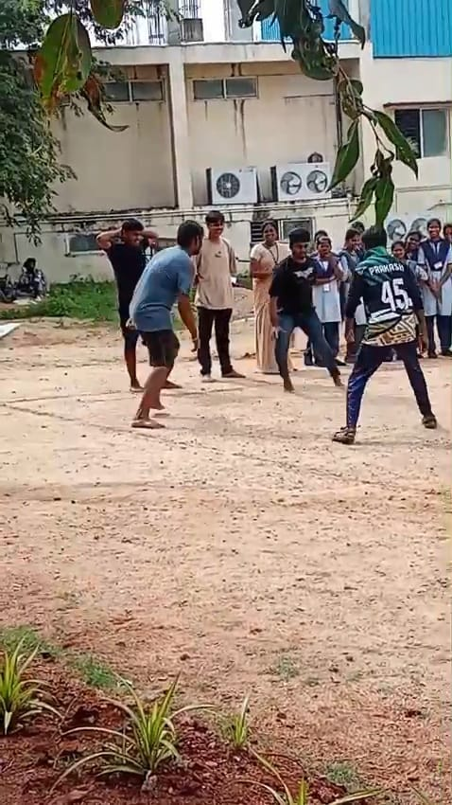

NATIONAL SPORTS DAY ORGANISED BY THE INSTUTUTION
2025-2026
S.NO | NAME OF THE PROGRAMME | NAME OF THE SPORT | NAME OF THE STUDENT (WINNERS) | ROLL NUMBER | NAME OF THE STUDENT  (RUNNERS)
 | National Sports Day | Kabaddi(B) | Teja Prakash | 22GT1T0015 | Sanjay
 | National Sports Day | Kabaddi(B) | Kamil Basha | 22GT1T0023 | Vardhan Reddy
 | National Sports Day | Kabaddi(B) | Jayaprakash | 22GT1T0007 | Sai Kiran
 | National Sports Day | Kabaddi(B) | Chandru | 22GT1T0004 | Malthesh
 | National Sports Day | Kabaddi(B) | Vishnuvardhan | 22GT1T0017 | Hari Tarun
 | National Sports Day | Kabaddi(B) | Nizam | 22GT1T0024 | Hemanth
 | National Sports Day | Kabaddi(B) | Stephen | 22GT1T0005 | Abinesh
 | National Sports Day | Kabaddi(G) | Jaswanthi | 24GT1R0006 | Sathvika
 | National Sports Day | Kabaddi(G) | Vidhya | 24GT1R0012 | Shaju nursisa
 | National Sports Day | Kabaddi(G) | Pavani | 22GT1R0059 | Sufya
 | National Sports Day | Kabaddi(G) | Anusha | 22GT1R0039 | Vyshnavi
 | National Sports Day | Kabaddi(G) | Poojitha | 24GT1R0018 | Kusuma
 | National Sports Day | Kabaddi(G) | Sandya | 24KU1R0024 | Sanjana
 | National Sports Day | Kabaddi(G) | Srilakshmi | 24GT1R0020 | Praneetha
 | National Sports Day | Kabaddi(G) | Poojitha | 24GT1R0028 | Malthi

